LEANFT WINDOWS INSTALLATION:

1. HPE SaaS <https://saas.hpe.com/en-us/download/leanft> .Sign into your account. If you don't have an account you would create one.
2. Click on download.
3. Select the LeanFT web package.

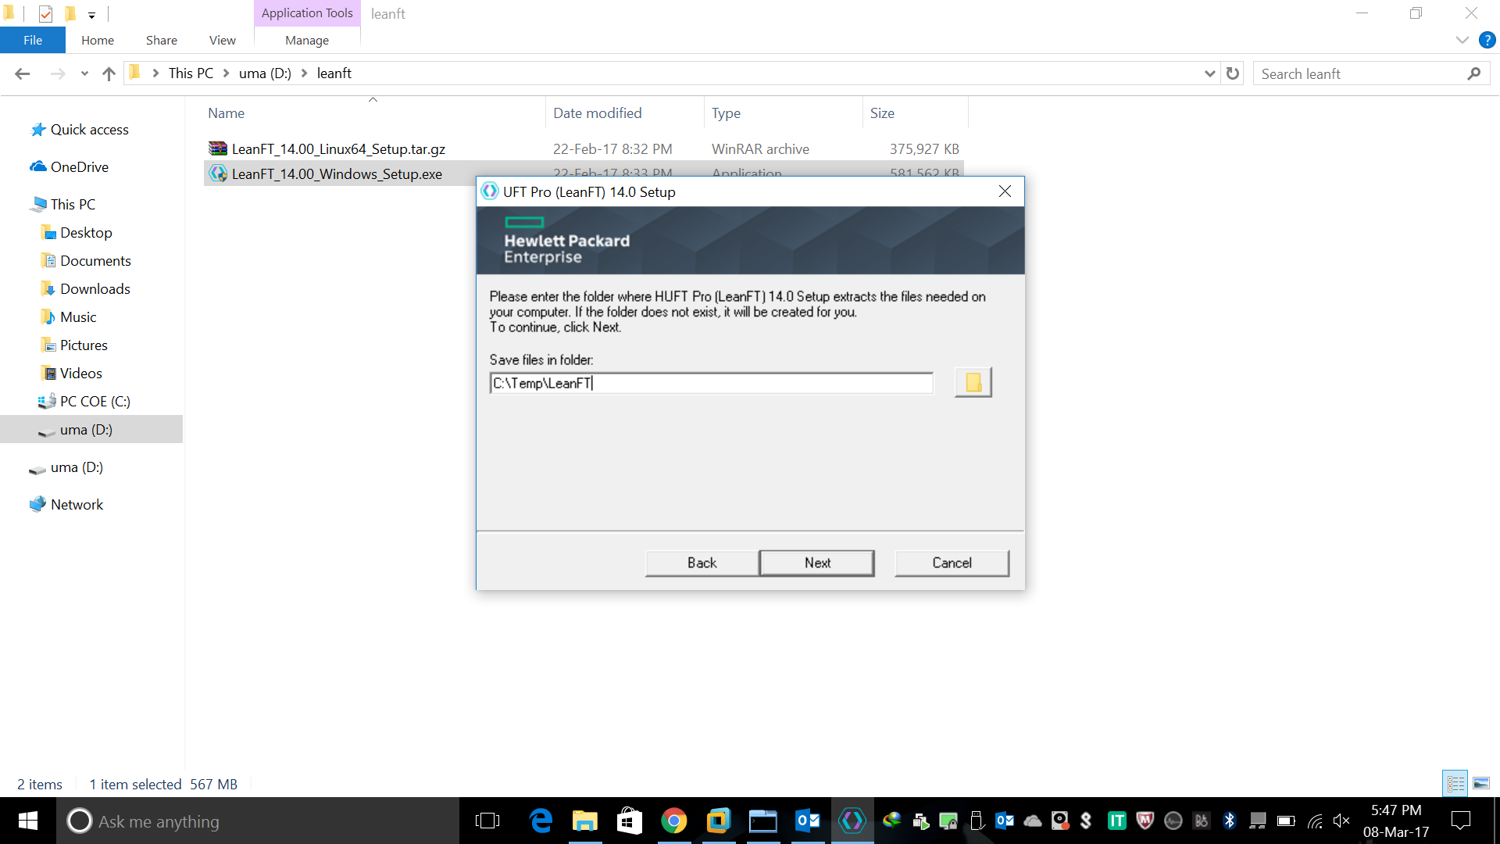

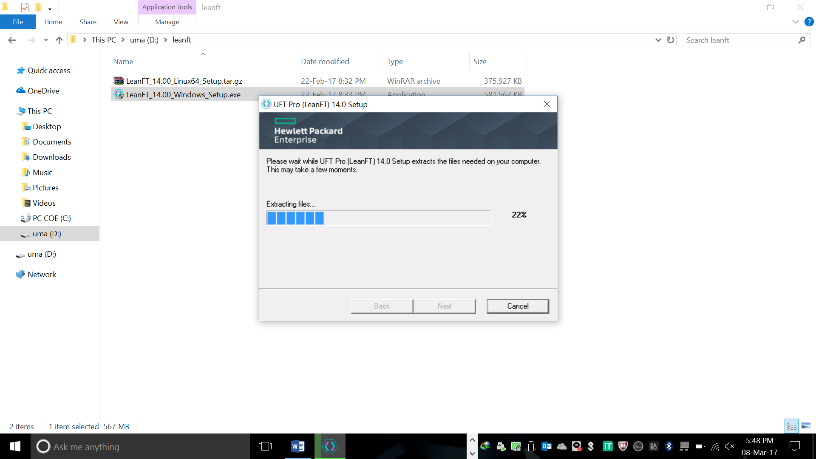

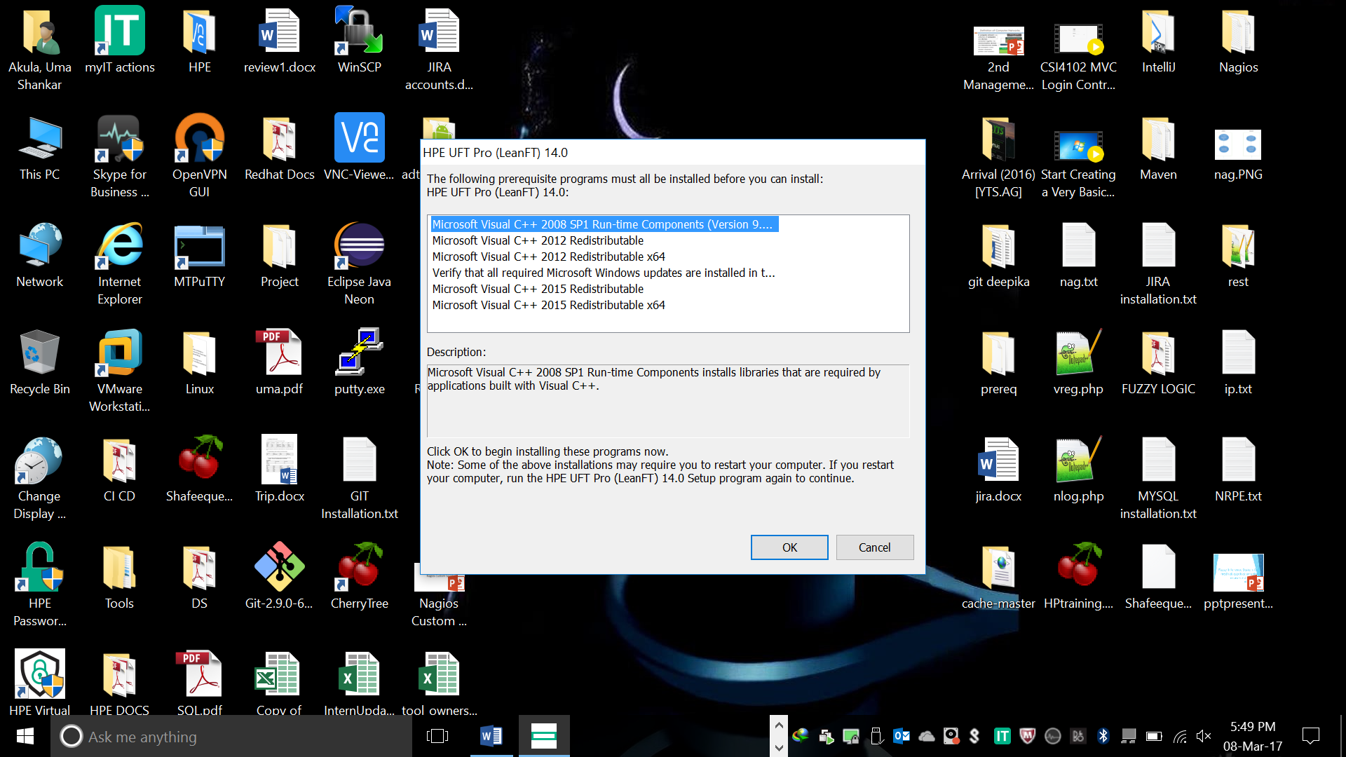

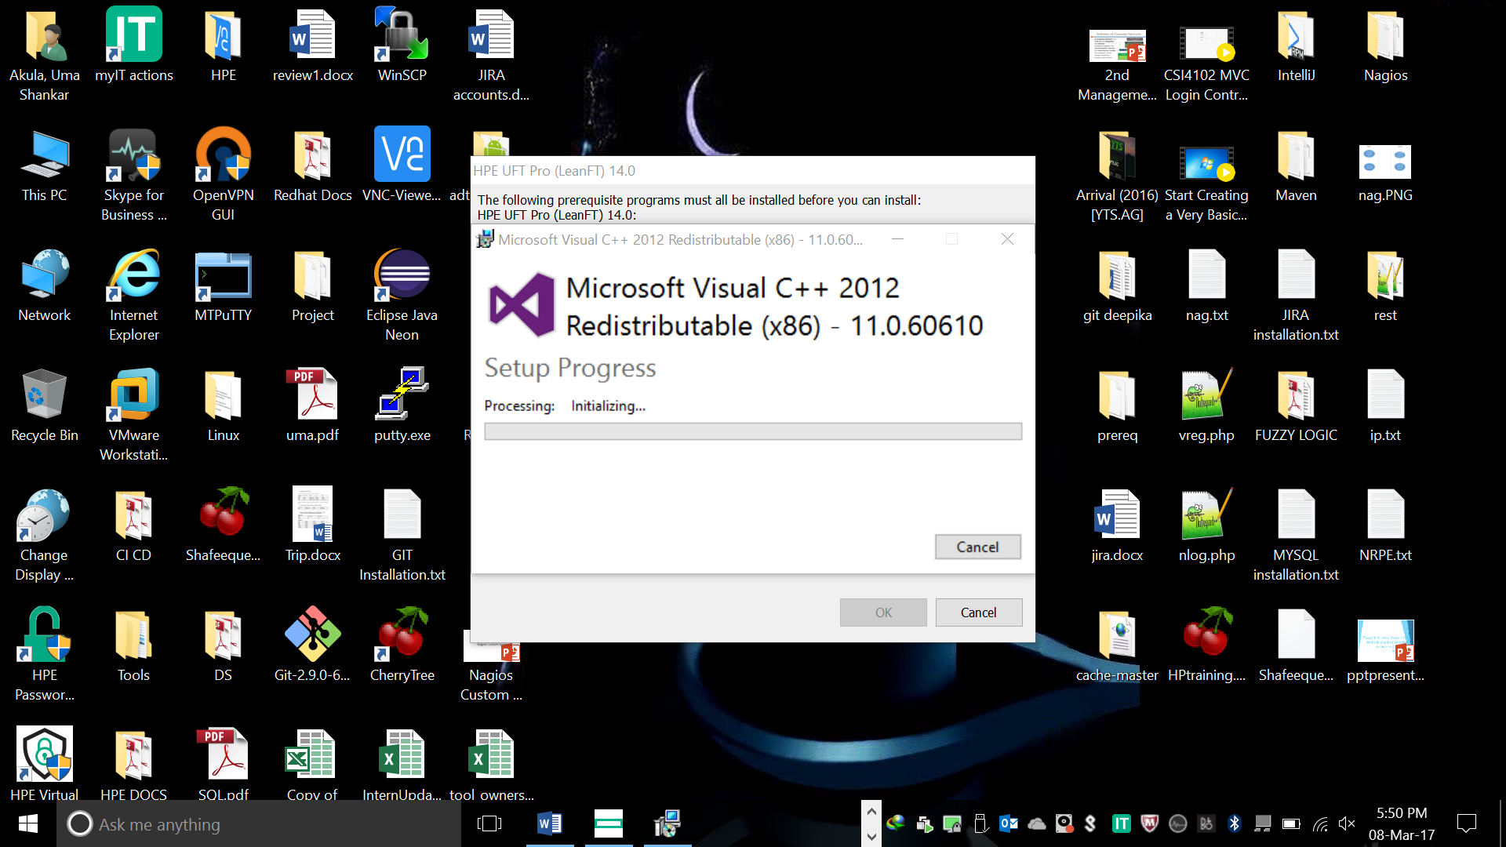

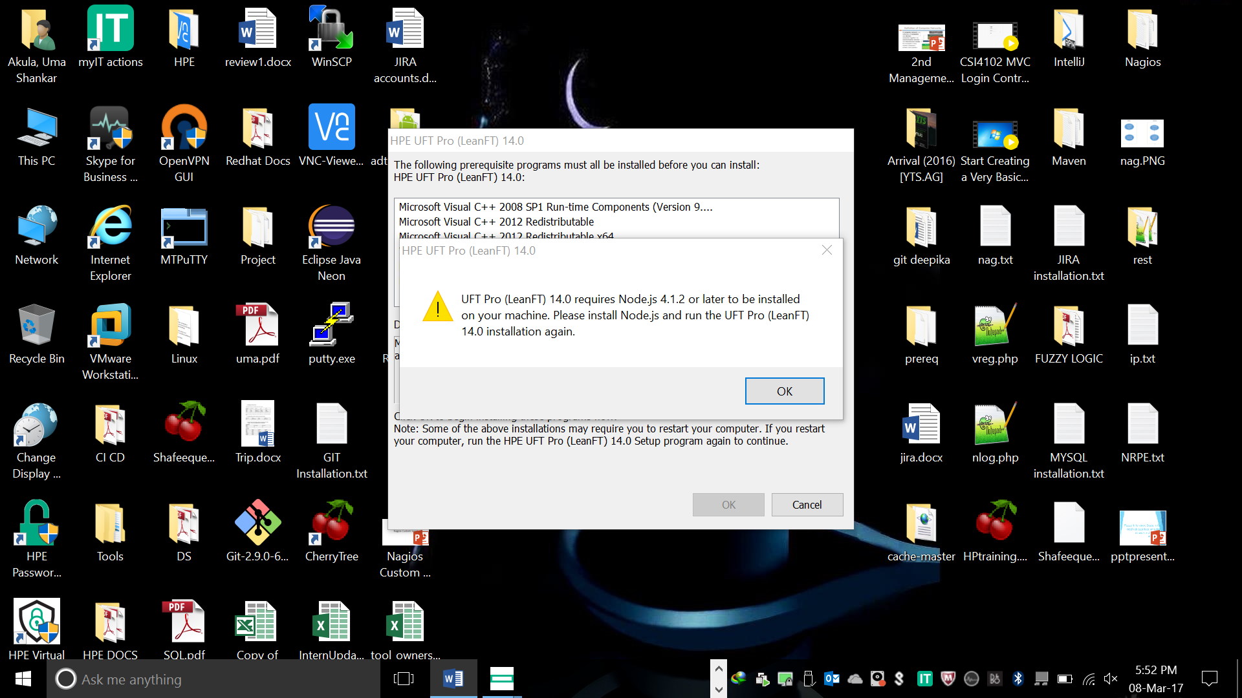

1. DOWNLOAD AND INSTALL:

<https://nodejs.org/en/blog/release/v4.1.2/>

Windows 64-bit Installer: <https://nodejs.org/dist/v4.1.2/node-v4.1.2-x64.msi>

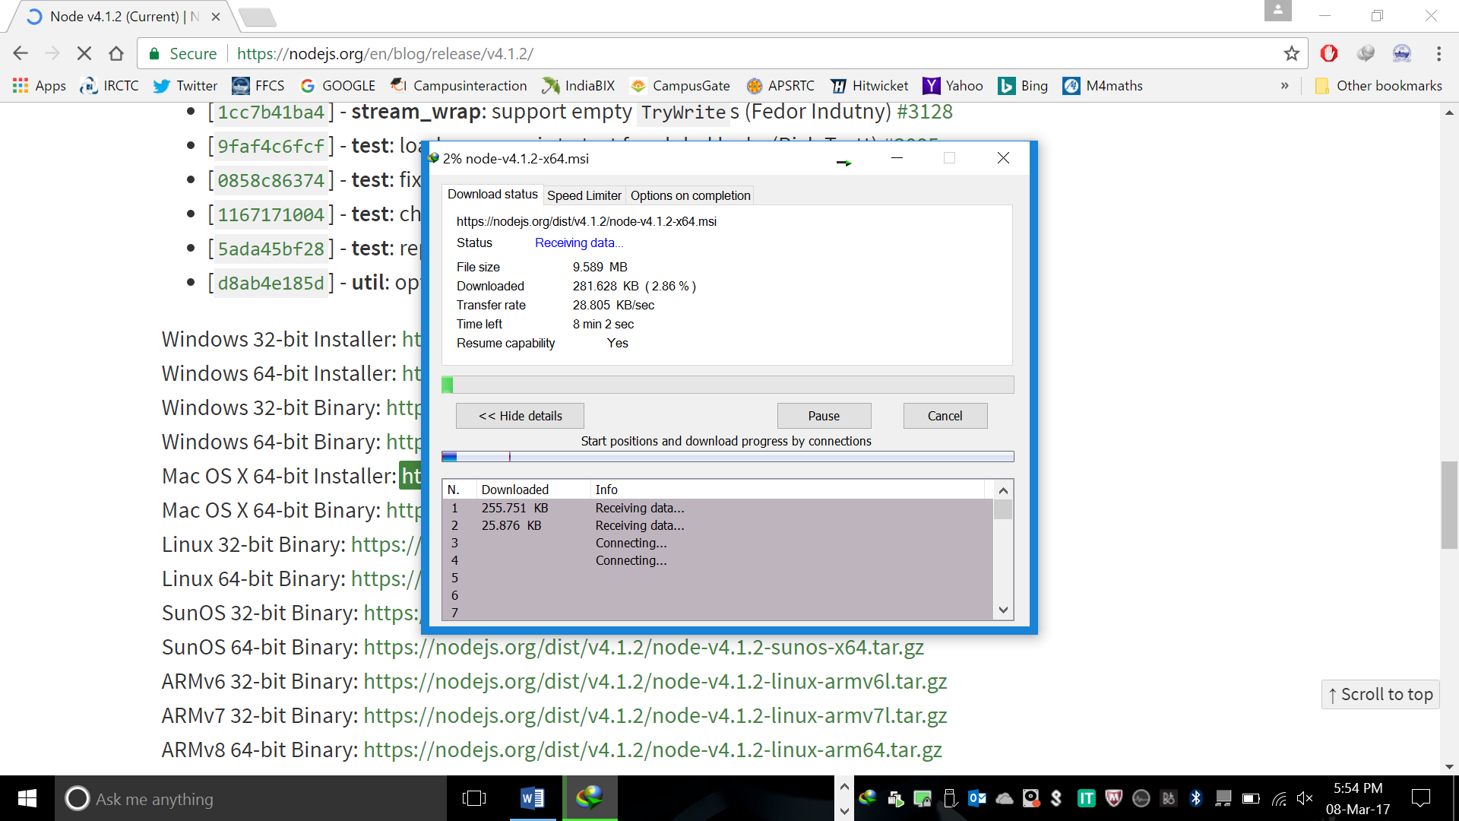

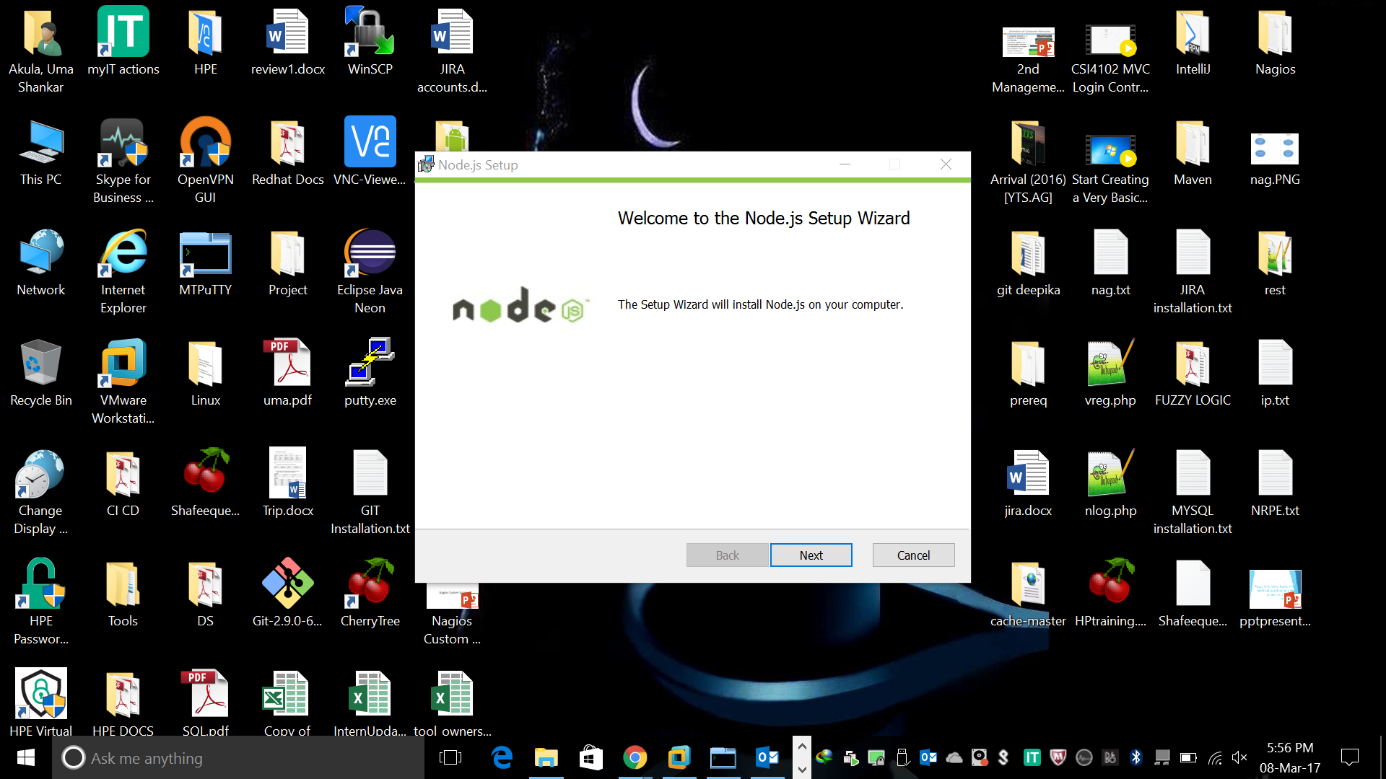

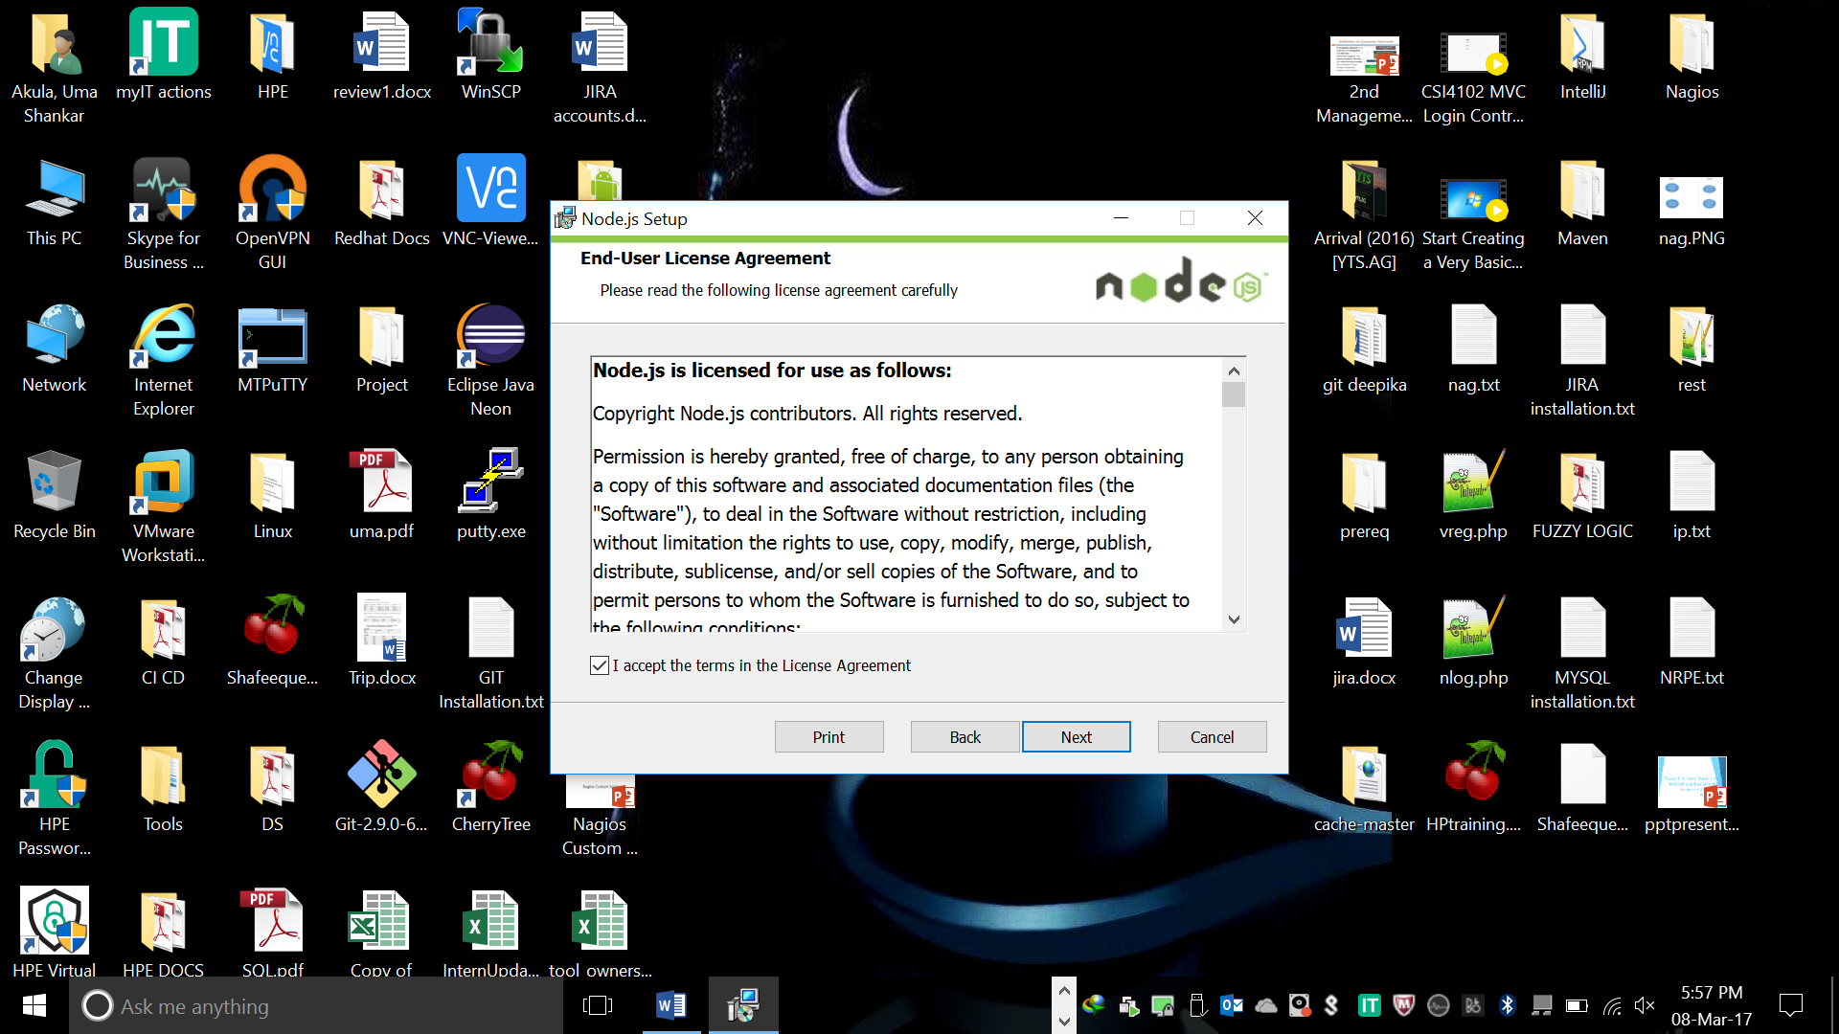

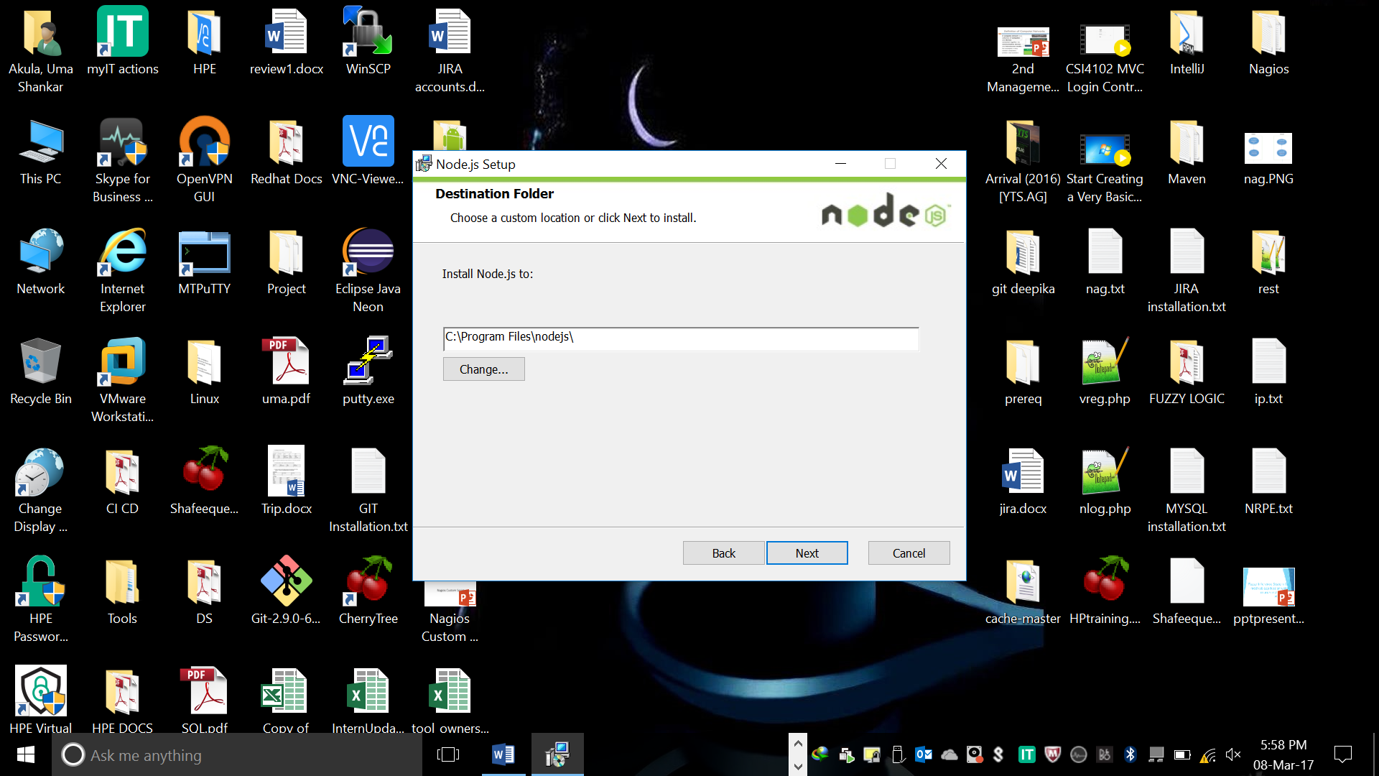

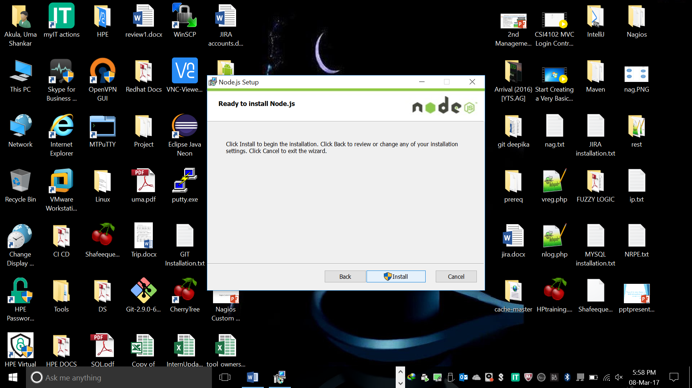

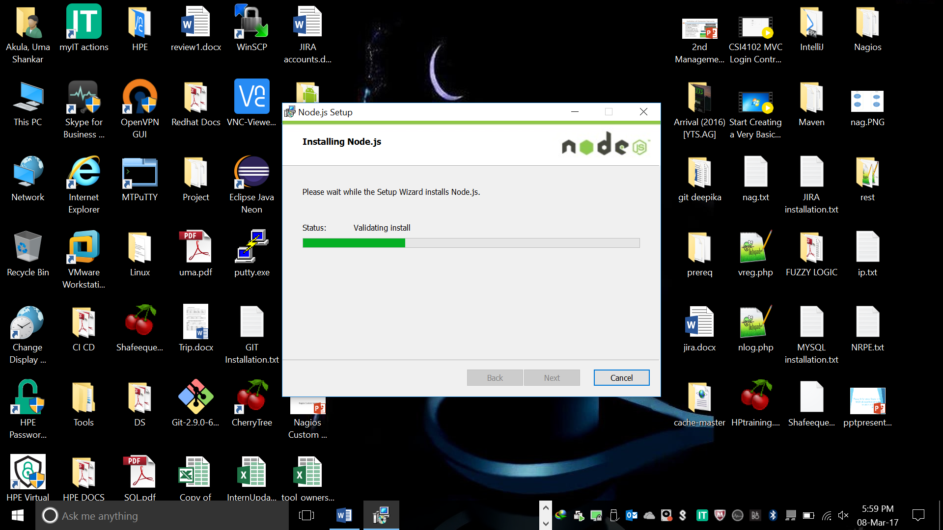

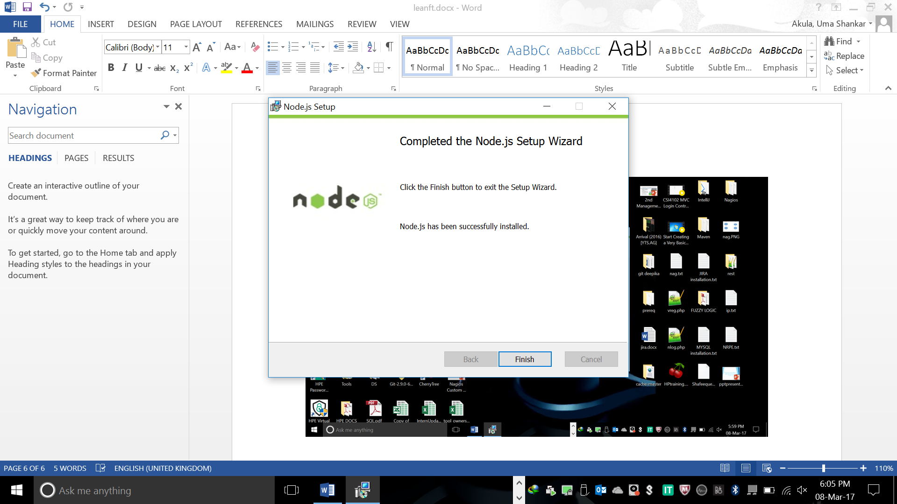

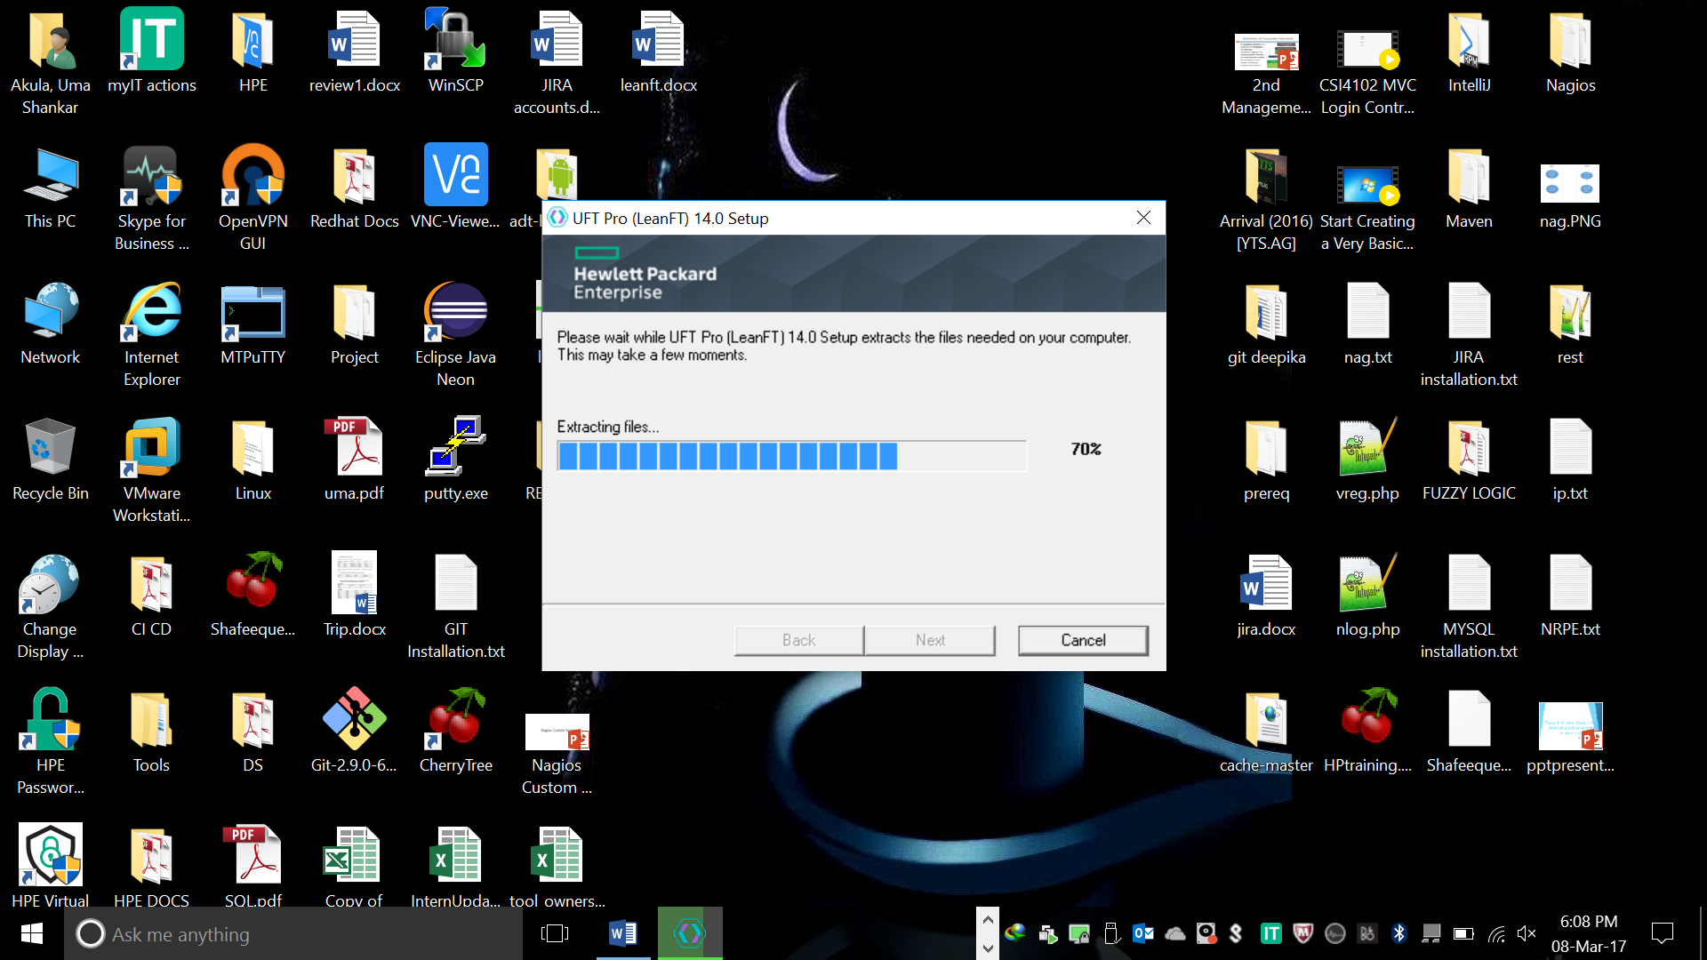

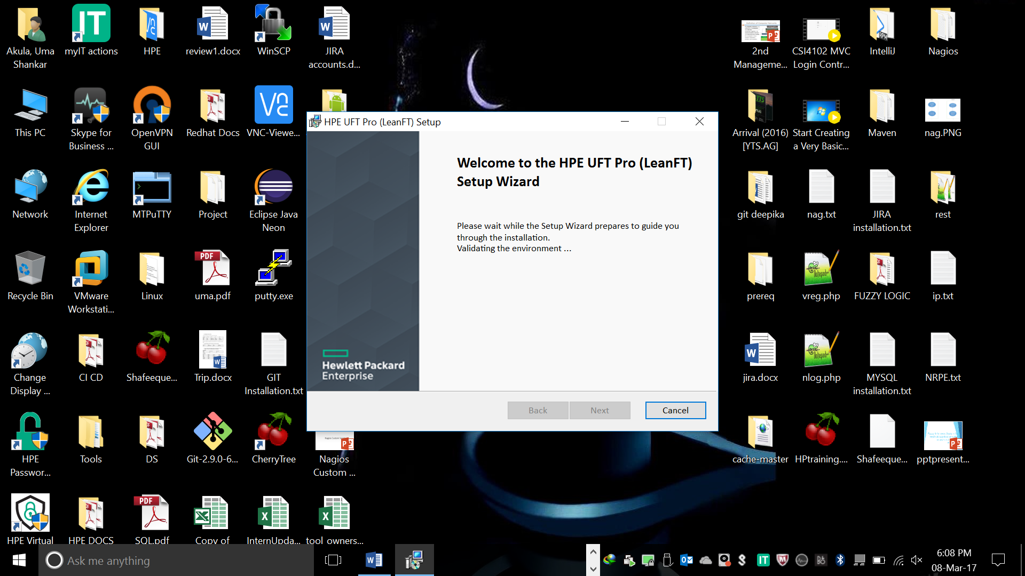

1. **Full installation:**

* **Eclipse**, a path field is displayed.  Click **Change** to browse to the folder where your Eclipse IDE is deployed.
* **IntelliJ IDEA**: If you have multiple versions of IntelliJ IDEA, click **Select versions** to select the version where you want to install the LeanFT plugin.
* **Note:** If you run the **Full installation**, but do not select any IDEs for the LeanFT plugin, the LeanFT SDKs are still installed in **<LeanFT installation>\SDK**.

